Name: Adilah binti Adi Yasran

Matric: 198989

JDBC Practical

JDBC (Java Database Connectivity) is a Java API that manages the database connection, issues queries and commands, and handles the result sets obtained from the database. The database used for this lab is MySQL.

Input in MySQL Workbench

Student table is created under db1 database. The table student has student details such as their id, name and department.

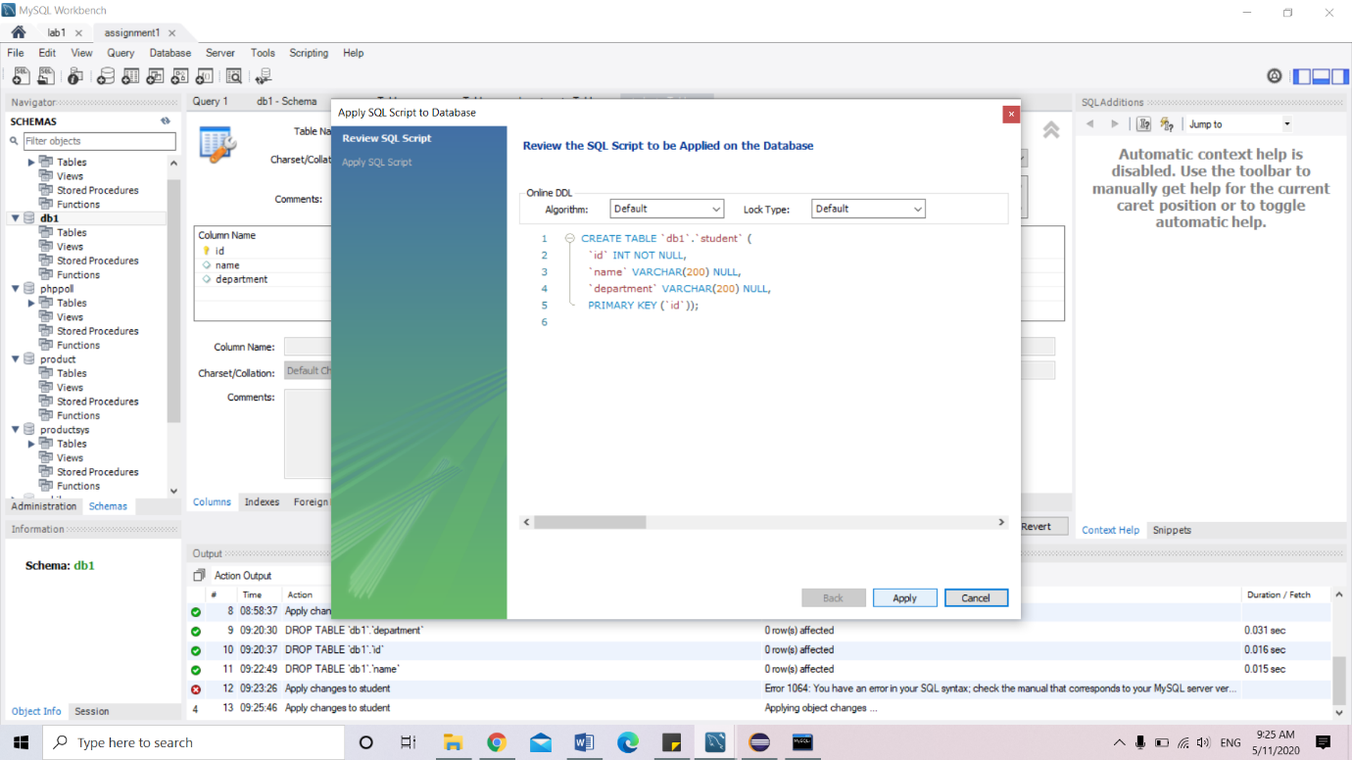

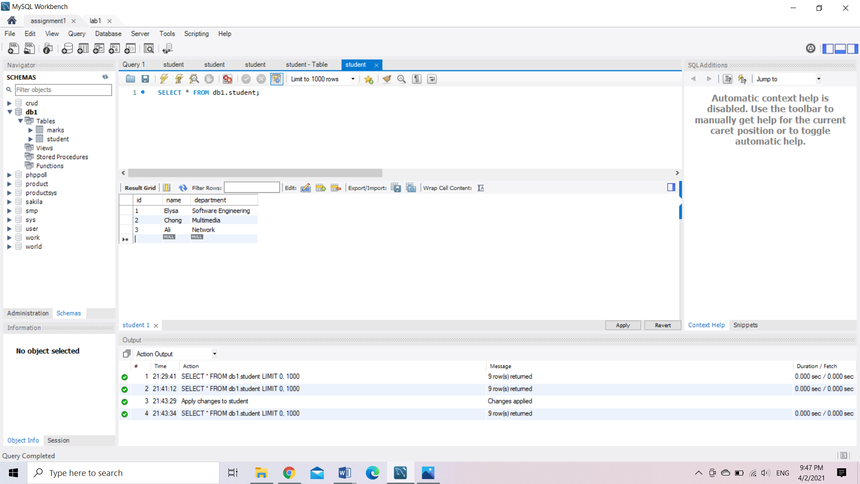

Output

The student.java class have retrieved the student information (id, name and department) from database (mySQL) by connecting it using JDBC and the output after run is shown in the console as the figure below.

